Subject line: Keep your goals in clear view.
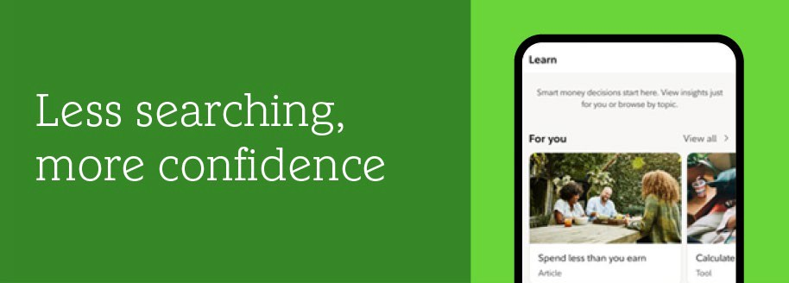
Get helpful financial education on Fidelity NetBenefits®
Spend less time searching and more time making conﬁdent ﬁnancial decisions. With a single spot for education, our learning experience on NetBeneﬁts makes it simple to ﬁnd resources and content on the topics that matter most to you.
- Get personalized insights, based on your unique ﬁnancial journey and how you prefer to learn
- Find what you need fast with comprehensive educational resources available via the NetBeneﬁts app and website
- Navigate ﬁnancial choices with trusted education on topics like retirement, investing, and more





The NetBenefits® app gives you more ways to access and manage your employee benefits. Download now or open the app

App Store is a registered service mark of Apple Inc. Google Play is a trademark of Google LLC.

Privacy Policy | Terms of Use
Investing involves risk, including risk of loss.
The information in this email is intended solely for the attention and use of the named addressee. This message or any part thereof must not be disclosed, copied, distributed, or retained by any person without authorization of the addressee.
Please do not respond to this email. This mailbox is not monitored, and you will not receive a response. NetBeneﬁts and the Fidelity Investments and pyramid design logo are registered service marks of FMR LLC. System availability and response times may be subject to market conditions.
Fidelity Brokerage Services LLC, Member NYSE, SIPC, 900 Salem Street, Smithﬁeld, RI 02917
© 2025 FMR LLC. All rights reserved. 1219593.2.0

